Supplemental experimental procedures
This document contains the supplementary material of the article entitled xx. The document is organized as follows…
S1. Economic assessment
In essence, we use data from process simulations to determine the energy and materials inputs and outputs as well as the necessary infrastructure associated with each chemical. We then estimate the OPEX and CAPEX expenditures for a reference year (xx), adjusting afterwards the results for other years using the CEPCI index to account for inflation. For the OPEX calculations, the natural gas prices is not adjusted for inflation but instead we consider its fluctuating price at any given point in time, which is based on historical market values. The hydrogen cost is considered as an OPEX expenditure and estimated from the electricity price and the electrolyzer cost.
S1.1. Ammonia. The inventories for both fossil and green ammonia are taken from the work done by D’Angelo et al.¹. In the case of fossil ammonia, every ton of ammonia produced consumes 0.53 tons of natural gas and 940 kWh of electricity¹. The prices of feedstock and utilities other than natural gas, electricity, and hydrogen are based on D’Angelo et al.¹. These prices (Table S1) are adjusted for inflation using the Chemical Engineering Plant Cost Index – CEPCI (from Table S2) when considering data for a different year². We consider the monthly average natural gas spot prices (i.e., prices for new contracts at the Title Transfer Facility (TTF) trading point) from World Bank³ (Fig. 1) and electricity prices from Ember⁴ (Fig. S1). Further, the levelized cost for on-shore wind and solar electricity and their corresponding capacity factors were retrieved from the International Renewable Energy Agency (IRENA) for 2019 to 2021 (except 2022)^{5–7}. Using these values, the levelized cost of hydrogen (LCOH) is calculated following as in D’Angelo et al.¹. Due to data gaps for 2022, we determine first the levelized cost of hydrogen for 2021 and then adjust it for inflation using the CEPCI (Table S2)². The levelized cost of electricity and hydrogen for the corresponding years are shown in Table S3 and Table S4, respectively. The LCOH calculations are described in section S1.3.
S1.2. Methanol. The inventories for fossil and green methanol are similarly retrieved from González-Garay et al.⁸ Every ton of fossil methanol consumes 0.65 tons of natural gas and 74 kWh of electricity⁸. The prices of natural gas (Fig. 1), electricity (Fig. S1), and hydrogen (Table S4) are substituted by those mentioned earlier in the case of ammonia, and all the other costs are adjusted for inflation (Table S5). The price of CO₂ from Direct Air Capture (DAC) is taken from Keith et al.⁹ and updated with the new natural gas prices (Fig. 1). For every ton of CO₂ captured using the DAC technology, 0.11 tons of natural gas is required⁹.
S1.3. Levelized cost of hydrogen (LCOH). The parameters used to calculate the LCOH for all on-shore wind and solar-based scenarios are shown in Table S6. A Proton Exchange Membrane (PEM) electrolyzer with a stack lifetime of 60000 hours is considered for the analysis¹. The equations used to calculate the LCOH for hydrogen production from water electrolysis using on-shore wind and solar electricity are as follows¹:
$$\text{Life span} \text{= }\frac{\text{stack lifetime × 100}}{\text{8760 × capacity factor}}$$
$$\text{Annual} {\text{H}}_{\text{2}}\text{ production =} \frac{\text{nominal }{\text{H}}_{\text{2}}\text{flow per stack × stack lifetime}}{\text{life span}}$$
$$\text{CAPEX} \text{=} \sum_{\text{i= -1}}^{\text{0}}{\frac{\text{nominal input power} \text{×} \text{capital cost} \text{× 0.5}}{{\text{(1 + interest rate)}}^{\text{i}}}}$$
$${\text{H}}_{\text{2}}\text{ produced = }\sum_{\text{i= 1}}^{\text{life span}}{\frac{\text{annual }{\text{H}}_{\text{2}}\text{production × }{\text{H}}_{\text{2}}\text{ production capacity}}{{\text{(1 + interest rate)}}^{\text{i}}}}$$
$$\text{with }{\text{H}}_{\text{2}}\text{ production capacity= }\left\{\begin{aligned}\text{0.5 i=1} \\ \text{1}\text{.0}\text{ i>1}\end{aligned}\right.$$
$$\text{Electricity cost} \text{=} \text{power demand electrolyzer }\text{×}\text{ LCOE ×} {\text{H}}_{\text{2}}\text{ produced}$$
$$\text{Other costs =} \sum_{\text{i= 1}}^{\text{life span}}{\frac{\text{nominal input power × capital cost × 0.04}}{{\text{(1 + interest rate)}}^{\text{i}}}}$$
$$\text{Plant decommissioning =} \sum_{\text{i= 1}}^{\text{life span}}{\frac{\text{nominal input power × capital cost × 0.1}}{{\text{(1 + interest rate)}}^{\text{i}}}}$$
$$\text{Equipment replacement costs =} \sum_{\text{i= 1}}^{\text{floor(}\frac{\text{life span}}{\text{7}}\text{)}}{\frac{\text{nominal input power × capital cost × 0.15}}{{\text{(1 + interest rate)}}^{\text{i}}}}$$
$$\text{OPEX} \text{=} \text{electricity cost} \text{+} \text{other costs} \text{+} \text{plant decommissioning} \text{+ equipment replacement costs}$$
$$\text{LCOH} \text{=} \frac{\text{CAPEX} \text{+} \text{OPEX}}{{\text{H}}_{\text{2}}\text{ produced}}$$
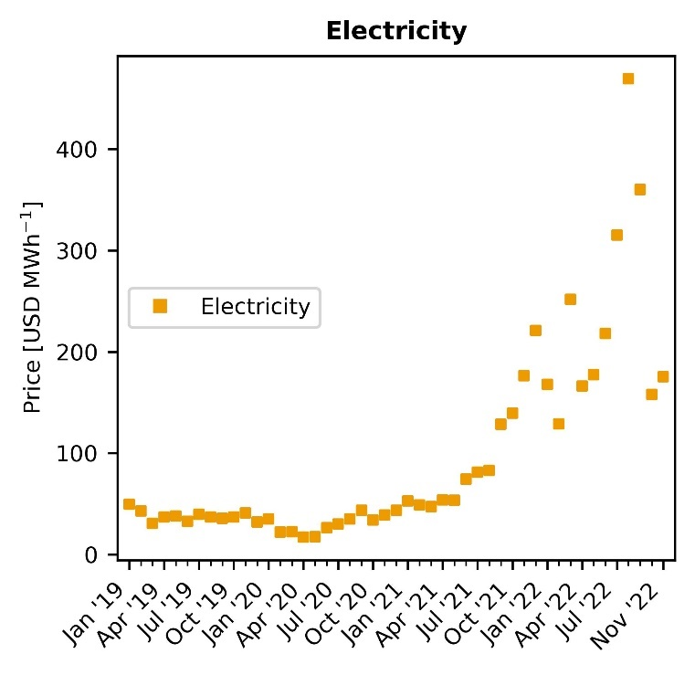
Fig. S1. Evolution of electricity prices in Europe⁴.

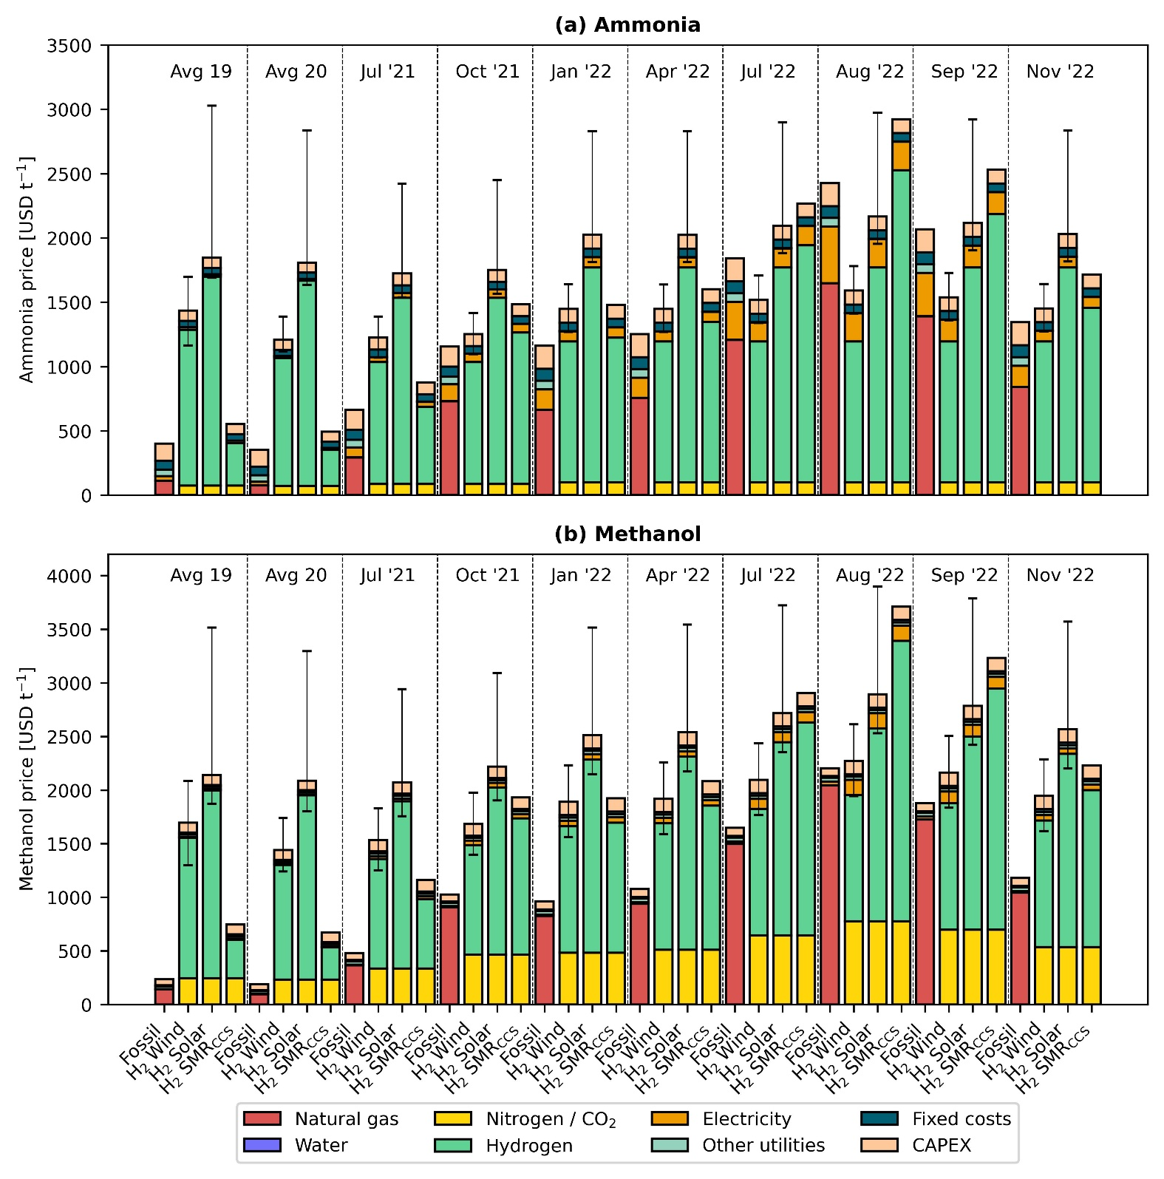
Fig. S2. Breakdown of production costs for fossil and green ammonia (a) and methanol (b). Error bars display the production cost considering the lower and upper bound for the levelized cost of hydrogen.

Table S1. Cost parameters used in the economic calculations for ammonia¹. All costs are presented in USD₂₀₁₉.
Flow | Average | Low | High
Water [USD t⁻¹] | 0.18 | - | -
Cooling water [USD GJ⁻¹] | 0.38 | - | -
CO₂ capture and storage [USD t⁻¹] | 15.84 | - | -
CO₂ emissions [USD t⁻¹] | 30.00 | - | -
Nitrogen [USD t⁻¹] | 91.06 | - | -

Table S2. CEPCI values from 2019 to 2022².
Year | CEPCI
2019 | 607.5
2020 | 596.2
2021 | 708.0
2022 (average till September) | 817.5

Table S3. Levelized cost of electricity in USD MWh⁻¹ and capacity factors (CF) in %^{5–7}.
 | 2019 |  |  |  | 2020
 | Average | Low | High | CF | Average | Low | High | CF
Wind - on shore | 67 | 37 | 96 | 35.6 | 45 | 35 | 65 | 36.0
Solar PV | 68 | 52 | 190 | 17.5 | 57 | 39 | 163 | 16.1

 | 2021
 | Average | Low | High | CF
Wind - on shore | 42 | 26 | 59 | 39.0
Solar PV | 48 | 29 | 120 | 17.2

Table S4. Levelized cost of hydrogen in USD t⁻¹. The methodology used to calculate the LCOH values is described in section 1.3.
 | 2019 |  |  | 2020
 | Average | Low | High | Average | Low | High
Wind - on shore | 6882 | 5232 | 8477 | 5636 | 5086 | 6736
Solar PV | 9217 | 8337 | 15927 | 9047 | 8057 | 14877

 | 2021 |  |  | 2022
 | Average | Low | High | Average | Low | High
Wind - on shore | 5379 | 4499 | 6314 | 6211 | 5195 | 7290
Solar PV | 8212 | 7167 | 12172 | 9482 | 8276 | 14055

Table S5. Cost parameters used in the economic calculations for methanol⁸. All costs are presented in USD₂₀₁₉.
Flow | Average | Low | High
Steam [USD t⁻¹] | 15.60 | - | -
Cooling water [USD m⁻³] | 0.03 | - | -
Catalyst [USD t⁻¹] | 136.38 | - | -
Wastewater treatment [USD m⁻³] | 1.64 | - | -
Carbon dioxide from DAC [USD t⁻¹] | 137.35* | 67.85* | 206.50*
*These prices do not include the natural gas cost required to capture carbon dioxide. One ton of carbon dioxide requires 0.11 tons of natural gas⁹.

Table S6. Parameters for the PEM electrolyzer¹. All values are in reference to the year 2019.
Component | Value
Nominal input power [kW] | 5000
Nominal hydrogen flow [kg hr⁻¹] | 89.9
Stack lifetime [hrs] | 60000
Power demand electrolyzer [kWh Nm³_{H2}⁻¹] | 5
Capital cost [USD kW⁻¹] | 1123.6
Interest rate [%] | 6.4
Decommissioning cost (fraction of depreciable capital) [%] | 10
Equipment replacement cost (fraction of initial CAPEX) [%] | 4
Construction period [years] | 2
Start-up period [years] | 1
Start-capacity [%] | 50

Note S1. Natural gas TTF spot prices.
For our calculations, we use Natural Gas TTF spot prices (monthly average). TTF stands for Title Transfer Facility, which is a virtual hub situated in the Netherlands where contracts are made based on both spot and future prices. In the past years, the TTF index has gained significant importance. It is now by far the most liquid, most traded hub, with the greatest number of participants of all the European traded hubs. Indeed, TTF has become a mature risk management hub, not just for the Netherlands but for all of Europe and beyond. TTF has grown almost exponentially in recent years, as evidenced by the the total volumes traded that now account for 79% of the total European traded gas markets. Moreover, TTF has become the pricing benchmark for North-West Europe, while several other countries across Europe will also use TTF to price contracts. TTF is also used to price some LNG cargoes destined for Europe.
Companies wishing to make new contracts for natural gas often rely on the TTF index for closing the new deals. Most of these companies make contracts based on future prices, which are agreed depending on the market conditions. However, if a company needs natural gas on the spot, it will be charged the spot prices according to the TTF index.
Even though not all of Europe uses the TTF index, based on the trading volumes and share of the European market, it seems sensible to use the TTF index for our analysis. Also, the spot prices might be higher than what the companies agree to in a contract based on the future trends. However, such data are hard to find or predict, so for this study, we use the spot prices instead.

Note S2. Ammonia model validation.
The cost estimates for ammonia were compared with data extracted from ICIS¹⁰ (Fig. S3). ICIS is xx. ICIS has published the production cost of ammonia for certain dates from October 2021 to October 2022 using the natural gas TTF spot prices. As shown in Fig. S3, our model is in good agreement with the values from ICIS except at the peak. This divergence can be explained by understanding the prices used by ICIS. ICIS calculates the peak on 26th August 2022, where the natural gas prices were around 4,519 USD t⁻¹, however we use monthly average prices in our analysis and for that reason the natural gas price we use at the peak (August 2022) is around 3,130 USD t⁻¹.
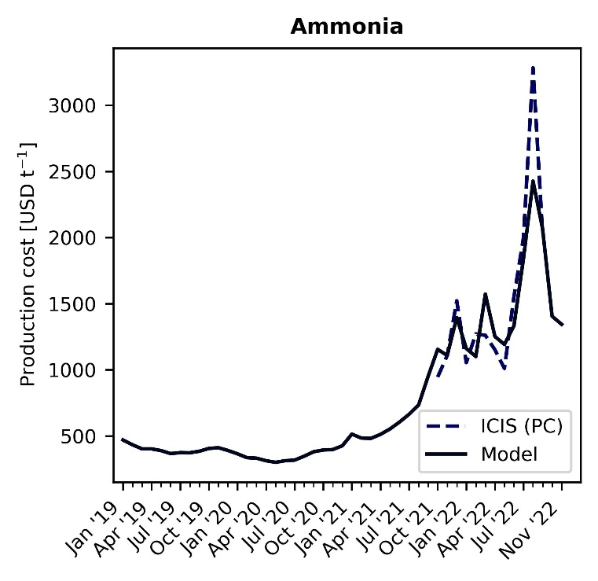
Fig. S3. Ammonia model validation¹⁰.
Note S3. Methanol model validation.
Market prices for methanol in Europe were retrieved from Methanex Corporation¹¹ (January 2015 to September 2022) and Methanol Marketing Services Asia - MMSA¹² (October 2019 to September 2022). MMSA is a consultancy service in Asia that provides limited information on the data sources. Methanex Corporation, on the other hand, is the world’s largest producer and supplier of methanol to major international markets. As shown in Fig. S4, the data from both Methanex and MMSA are quite similar. Methanex has production sites in countries like Trinidad, New Zealand, Egypt, Canada, the United States, and Chile.
When comparing the cost of production calculated from our model and the market price of methanol, we see that from January 2015 to January 2021, the production costs are close to the market prices of methanol. However, when the natural gas prices start becoming more volatile, our model predicts production costs that are way higher than the market price of methanol in Europe. The reasons for this mismatch could be as follows:
- Methanex has production sites in countries not affected by the current volatility of natural gas prices and hence produce methanol at a much lower price. When this methanol is exported to Europe, the market price is expected to be lower than the cost of production in Europe where the natural gas prices are the most impacted.
- Methanex and MMSA report the market prices of methanol. These prices are not the same as the cost of production in Europe. Moreover, methanol can be imported from overseas and then sold in Rotterdam. Hence, the production costs could be much lower than our predictions for EU as cheaper natural gas from somewhere else in the world might have been used as feedstock.

- Our model uses monthly average spot prices of natural gas TTF. Companies might not buy natural gas at these prices, as they might rely on established contracts. However, we would expect that the price of natural gas agreed upon in deals closed since the outbreak of the energy crisis would depend on the natural gas TTF index. Therefore, our estimates do not correspond to actual market values, but to the minimum selling prices in the market if those chemicals were produced in EU at the corresponding natural gas prices.

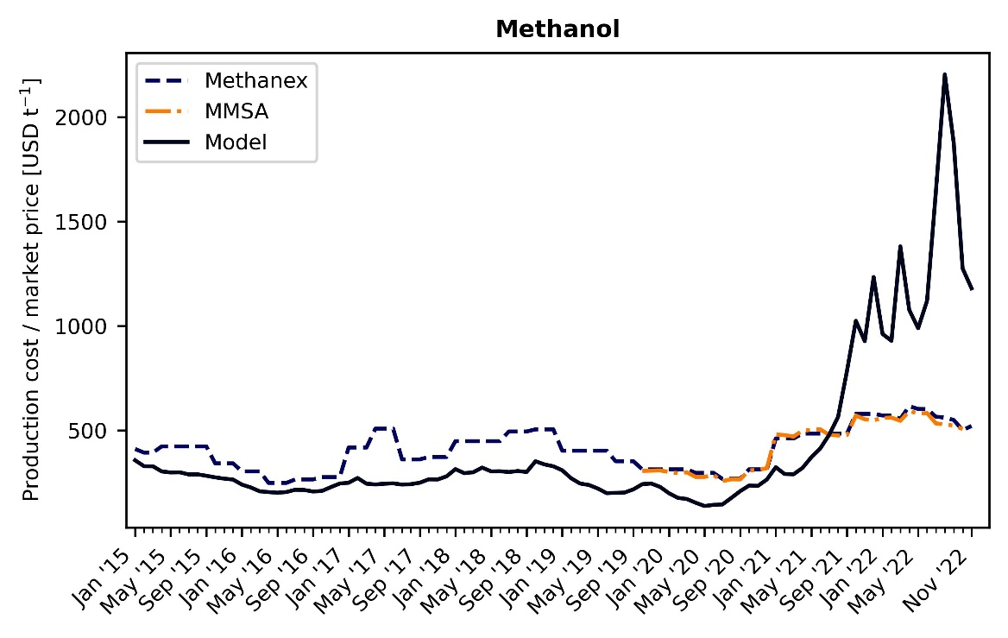
Fig. S4. Methanol cost of production (model) vs market price (literature)^{11,12}.
References
1. D’Angelo, S.C., Cobo, S., Tulus, V., Nabera, A., Martín, A.J., Pérez-Ramírez, J., and Guillén-Gosálbez, G. (2021). gAmmonia - main paper. ACS Sustain Chem Eng 9, 9740–9749. 10.1021/acssuschemeng.1c01915.
2. Charles Maxwell (2022). Cost Indices. Towering Skills.
3. World Bank (2023). Monthly Prices, Commodity Markets. World Bank.
4. Ember (2022). European wholesale electricity price data. Ember.
5. International Renewable Energy Agency (2020). Renewable Power Generation Costs in 2019.
6. International Renewable Energy Agency (2021). Renewable Power Generation Costs in 2020.
7. International Renewable Energy Agency (2022). Renewable Power Generation Costs in 2021.
8. González-Garay, A., Frei, M.S., Al-Qahtani, A., Mondelli, C., Guillén-Gosálbez, G., and Pérez-Ramírez, J. (2019). Plant-to-planet analysis of CO2-based methanol processes. Energy Environ Sci 12, 3425–3436. 10.1039/c9ee01673b.
9. Keith, D.W., Holmes, G., st. Angelo, D., and Heidel, K. (2018). Carbon dioxide - DAC. Joule 2, 1573–1594. 10.1016/j.joule.2018.05.006.
10. Deepika Thapliyal (2022). INSIGHT: Crashing gas spurs fertilizer ramp up, petchems still shuttered. Independent Commodity Intelligence Services (ICIS).
11. Methanex Corporation (2022). Historical Methanex Posted Price. Methanex Corporation.
12. Methanol Marketing Services Asia (MMSA) (2022). Global Methanol Pricing Comparison. Methanol Market Services Asia.

